**About Your Counselor**

Jeff Pearsall has served the West Chester community as a school counselor at Penn Wood School, Peirce Middle School, and East High School.

Mr. Pearsall delivered nearly 200 developmental guidance lessons in 20 classrooms in 2015-16 on topics ranging from Second Step Pro-Social Skills (1-3) to Life Skills Training (Grs. 3-4) to Career Development Lessons (Gr. 5).

How Students See the Counselor

* Self-Referral
* Parent Referral
* Teacher Referral
* Administrative Referral
* Counselor Referral
* Request of a Friend or Classmate

**What Will A Child Do**

**In the Counselor’s Office?**

* Draw A Picture
* Play a Game
* Read a Short Book
* Learn New Friendships Skills
* How to Deal with Various Feelings

[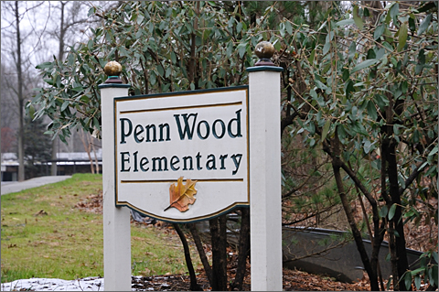](http://www.google.com/url?sa=i&rct=j&q=&esrc=s&source=images&cd=&cad=rja&uact=8&ved=0CAcQjRxqFQoTCLmE0ae6jsgCFUxxPgod3kMFAw&url=http://www.westernskycommunications.com/2013/01/11/photo-essay-on-again-off-again-winter/&bvm=bv.103388427,d.cWw&psig=AFQjCNE0CQ7SBgh-tJ60g7bj4EpuFbYmKg&ust=1443142259967761)

Key Elements of Penn Wood School Counseling Program



**Contact *Information***

Phone: 484-266-1911

Email: [jpearsall@wcasd.net](mailto:jpearsall@wcasd.net)

Web: guidancehappenings.weebly.com

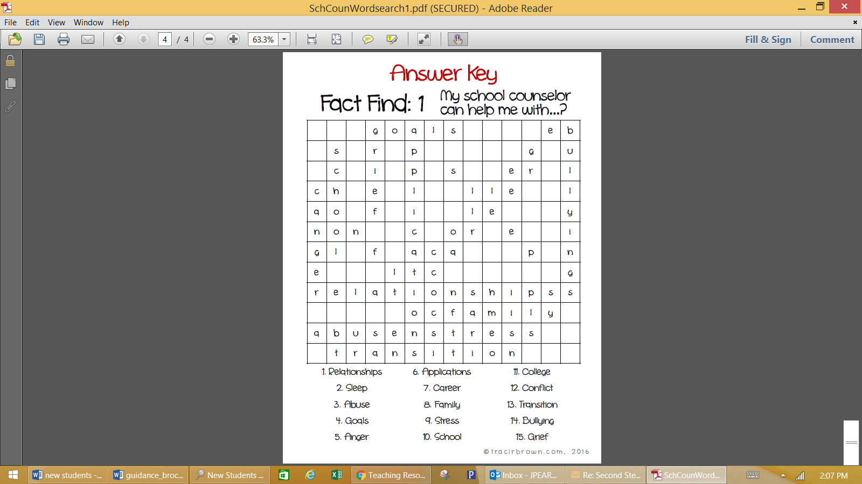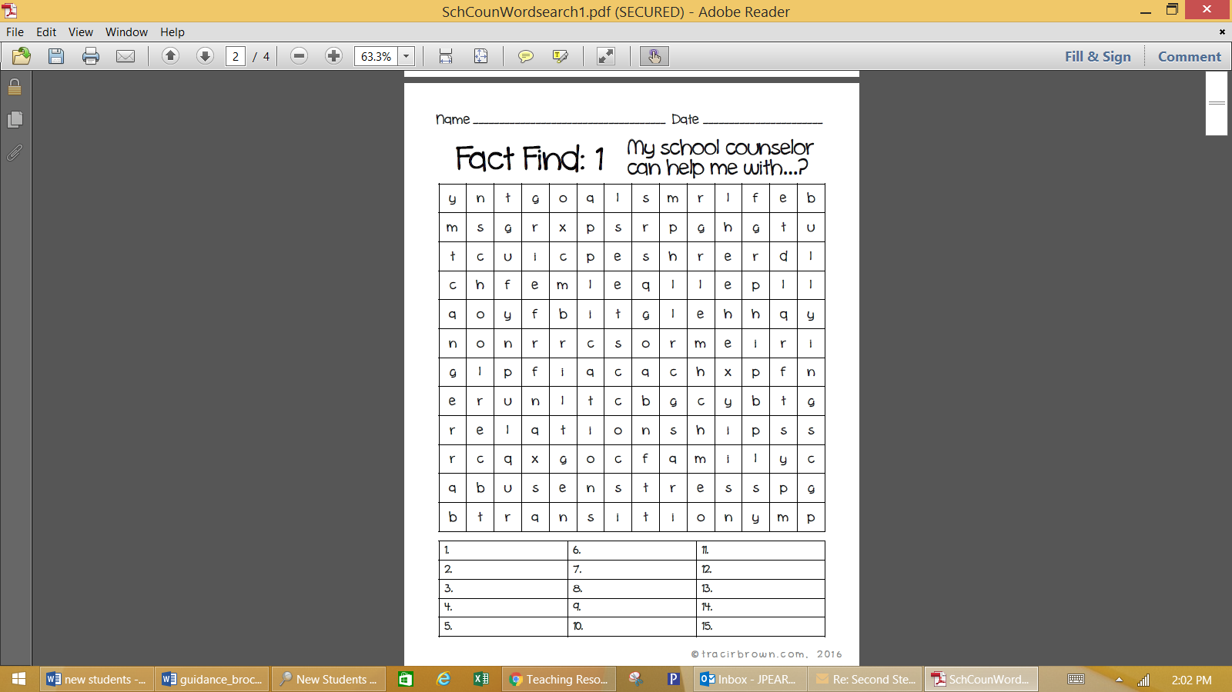

**Highlights of Penn Wood School Counseling Program**

**Individual and Small Group Counseling in Following Areas**

* Friendship and Social Skills Training
* Dealing with Feelings—Frustration and Anger Management
* School and Social Anxiety
* Grief and Loss—Changing Families
* Study Skills and Motivation

**Parent Consultation**

**Emphasis on Character Education—6 Pillars of Character**

**Bulldoze Bully Club**

**Penn Wood PAWS**

**Developmental Guidance Lessons (K-5)**